New Directions in Health
COMPREHENSIVE HEALTH PROFILE

Last Name _____________________________________First Name____________________________________

Date Of Birth_____/_____/____ Gender M F Todays Date__________________________________

D M Y

Address:_____________________________________City:________________________Prov_______________

Postal Code__________Home Tel._____________Bus. Tel.__________________Cell._____________________

E-Mail_________________________________________Occupation____________________________________

Who referred you and how did you discover our clinic? _____________________________________________

Have you ever seen a Chiropractor before? YES NO / Date__________________________________

Have you ever seen a Massage Therapist before? YES NO

Primary care physician:

Name ___________________________Address_____________________________Phone ._________________

INSTRUCTIONS:

This questionnaire contains 5 sections. Unless you are specifically instructed to fill out certain sections we would like you to complete the whole questionnaire.

SECTION 1: HEALTH/TRAUMA/MEDICAL/CHIROPRACTIC/HEALING HISTORY

What is your primary reason for your visit today?______________________________________________________

Have you ever injured your body (neck, head, back, hips)? YES NO

If yes, please describe___________________________________________________________________________

Have you had any spinal x-rays, CT scans or MRI imaging? YES NO. If yes, when?
_____________________________________________________________________________________________

What were you told?____________________________________________________________________________

Please list any major illnesses, hospitalizations, operations, or surgeries you have had and the year which they ocurred?___________________________________________________________________________________
__________________________________________________________________________________________

Please list all medications, vitamins, herbs, supplements you are presently taking and the reasons for taking them?_____________________________________________________________________________________

_______________________________________________________________________________________________________________

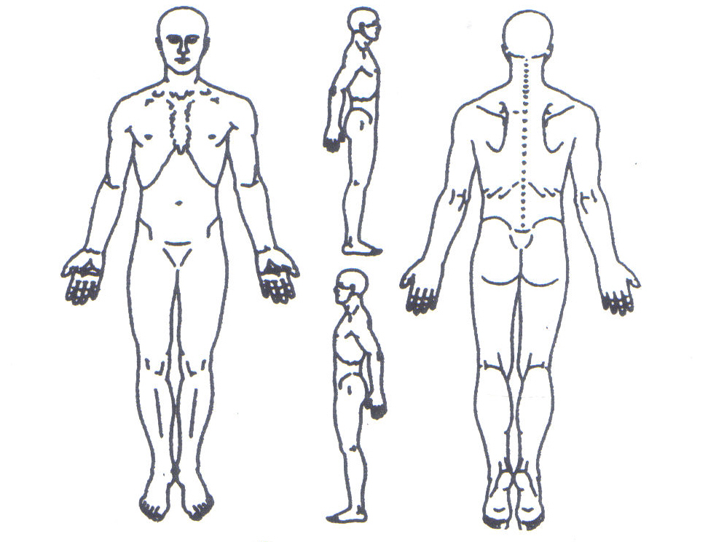
PLEASE USE THE DIAGRAM BELOW TO SHOW US WHERE AREAS OF PAIN OR UNUSUAL FEELING ARE:

Please check the conditions that are applicable to you:

Respiratory Skin

Current Previous Current Previous
-  Chronic cough   Skin condition;
-  Bronchitis type:___________
-  Shortness of breath   Bruise easily
-  Asthma   Plantar warts
-  Emphysema   Rashes
  Loss of sensation;
Cardiovascular location:____________
Current Previous   Eczema/psoriasis;
  Heart attack; date_________ location:____________
  Phlebitis
  Stroke; date: _____________
  Pacemaker Infectious Conditions
  High blood pressure Current Previous
  Low blood pressure   Tuberculosis
  Chronic congestive heart   Hepatitis; type: ______ failure   HIV
  Heart disease
Surgical Implants
 Pins  Wires
Digestive/Urinary  Artificial joints or special equipment

Current Previous
  Difficult digestion
  Liver/gall bladder Other Conditions
  Kidney/urinary bladder Current Previous
  Crohn’s disease/colitis   Hemophilia
  Diabetes; onset: ___________   Epilepsy
type:____________________   Cancer; location:_____
  Ulcers   Arthritis; ( ) RA ( ) OA
( ) other; location:_____
Muscles/Joints Pain or Discomfort   Fibromyalgia
Current Previous   Chronic fatique syndrome
  Neck   Osteoporosis
  Shoulders   Polio or post-polio syndrome
  Upper back   Scoliosis
  Middle back   Carpal Tunnel Syndrome
  Lower back   Herniated disc; location_______
  Hip   Muscle sprain/Ligament strain
  Knee   Tendonitis/Bursitis
  Ankle   Fracture; location:____________
  Other: ___________________   Whiplash; when?_____________
  Vision or hearing loss

Female   Headaches

Current Previous   Dizziness
  Gynaecological condition;   Ringing in the ears
type:_________________________   Fainting
  Pregnant; due date:______________   Other____________________________
_________________________________
SECTION 2:
YOUR HEALTH CONCERN/SYMPTOMS AND HOW THEY MAY AFFECT YOUR LIFE.

Do you have a main health concern? If so, please describe:_______________________________________
_______________________________________________________________________________________

When did it begin?________________________________________________________________________
Have you seen anyone for your concern?  YES  NO

If yes, who? and what were you told?_________________________________________________________
________________________________________________________________________________________

What was done?________________________________________Did it seem to work?__________________
Have any other family members had the same or similar concerns?  YES  NO

PLEASE GRADE THE LEVEL TO WHICH THIS HEALTH CONCERN(S) AFFECTS THE FOLLOWING ASPECTS OF YOUR LIFE
0 – It does not seem to affect me
1 – It seems to slightly affect me
2 – It seems to moderately affect me
3 – It seems to drastically affect me
affect on work 0 1 2 3 affect on family/relationships 0 1 2 3
affect on social life 0 1 2 3 affect on standing 0 1 2 3
affect on exercise/play 0 1 2 3 affect on walking 0 1 2 3
affect on love life 0 1 2 3 affect on sitting 0 1 2 3
affect on energy and vitality 0 1 2 3 affect on rest/sleep 0 1 2 3
my overall concern about my condition(s)/health 0 1 2 3

Why do you think this happened, or continues to happen to you?
_________________________________________________________________________________________

Do you think this is the sole cause? YES NO

If no, what else is involved?___________________________________________________________________
__________________________________________________________________________________________

If this condition/symptom were to go away tomorrow, what would be different about your life?______________________________________________________________________________________

Are you doing anything differently because of this condition/symptom? Concern?
__________________________________________________________________________________________

SECTION 3: STRESS SURVEY

PLEASE GRADE THE FOLLOWING STRESSES ACCORDING TO THE KEY BELOW
0 – No awareness of stress
1 – Slightly stressful situation
2 – Moderately stressful situation
3 – Extremely stressful situation
OVERALL PHYSICAL STRESS /TRAUMA: includes: falls, accidents, injuries, repeated
0 1 2 3 postural stress, impacts, difficult birth,
traction, physical abuse, etc.
OVERALL EMOTIONAL/MENTAL STRESS: includes: loss of love ones, rapid change in life
0 1 2 3 situation, mental, emotional, sexual abuse, legal
concerns, financial concerns, move of home/school,
separation/divorce etc. in relationship, stress of
being ill. etc.
OVERALL CHEMICAL STRESS: includes: drugs, smoke, fumes, food additives, poor nutrition, etc.
0 1 2 3
CURRENTLY I WOULD GRADE MY OVERALL STRESS LEVEL TO BE:
0 1 2 3

SECTION 4: YOUR SPECIFIC NEEDS AND HOPES FOR HELP IN THIS OFFICE?

USE THE KEY BELOW FOR THE QUESTION THAT FOLLOWS:

0 – Does not apply
1 - Not so important to me
2 – Important to me
3 – Very important to me

In a published study conducted at the University of California - Irvine’s Medical School, patients under a specific Chiropractic approach called Network Spinal Analysis reported improvement in all of the categories of health and wellness listed below. How do you hope to benefit from Chiropractic care in this office?

- _______ Improvement in my physical symptoms
- _______ Improvement in my emotional/mental state
- _______ Improvement in my ability to handle stress
- _______ Improvement in my ability to make constructive choices for
myself
- _______ Improvement in my vitality and enjoyment of life
- _______ Overall improvement in my quality of life

When communicating to you about your body, health and wellness (circle your preference).

- Mostly speak with me about the clinical findings. Tell me about the changes I am making.
- Mostly show me in written form the clinical findings. Let me see the changes that I am making.
- Mostly let me get a sense of the clinical work. Help me to feel the difference in my body.

Is there anything else which may help us to understand you, your history, or your professional needs which have not been discussed in this survey?___________________________________________________________________________
_________________________________________________________________________________

What would motivate you to tell others about the care you receive in this office, and encourage others to get care?__________________________________________________________________________
__________________________________________________________________________________

SECTION 5: INFORMED CONSENT & CANCELLATION POLICY

Informed Consent and Cancellation Policy for Massage Therapy

I understand massage therapy and other advanced soft-tissue modalities given here are for the purpose of stress reduction, relief from muscular tension/spasm and/or for increased circulation. I further understand that massage therapists do not diagnose illness, disease, or any other physical or mental disorder, and it is recommended that I see a physician for diagnosis or medical treatment.

I also understand that appointment times have been set aside especially for me. Should I fail to give 24 hours notice before canceling my Massage Therapy, Aromatherapy, Reflexology, Active Release Technique, or Reiki appointment, I agree to pay the fee of $40.00. The fee will be adjusted proportionately for longer appointment times.

By signing below, I have read and agree to the above consent and cancellation policy.

____________________________________________ ___________________________________

Patient’s Signature Date

Informed Consent for Chiropractic Care and Network Spinal Analysis

There are risks and possible risks associated with manual therapy techniques used by doctors of chiropractic. In particular you should note:

- While rare, some patients may experience short term aggravation of symptoms or muscle and ligament strains or sprains as a result of manual therapy techniques. Although uncommon, rib fractures have also been known to occur following certain manual therapy procedures;

- There are reported cases of stroke associated with visits to medical doctors and chiropractors. Research and scientific evidence does not establish a cause and effect relationship between chiropractic treatment and the occurrence of stroke rather, recent studies indicate that patients may be consulting medical doctors and chiropractors when they are in the early stages of a stroke. In essence, there is a stroke already in progress. However, you are being informed of this reported association because a stroke may cause serious neurological impairment or even death. The possibility of such injuries occurring in association with upper cervical adjustment is extremely remote;

- There are rare reported cases of disc injuries identified following cervical and lumbar spinal adjustment, although no scientific evidence has demonstrated such injuries are caused, or may be caused by, spinal adjustments or other chiropractic treatment;

- There are infrequent reported cases of burns or skin irritation in association with the use of some types of electrical therapy offered by some doctors of chiropractic.

I acknowledge I have discussed, or have had the opportunity to discuss, with my chiropractor the nature and purpose of chiropractic treatment in general and my treatment in particular (including spinal adjustment) as well as the contents of this Consent.

I consent to the chiropractic treatments offered or recommended to me by my chiropractor, including spinal adjustment. I intend this consent to apply to all my present and future chiropractic care.

______________________________________________________ ___________________________
Patient’s/Guardian’s Signature Date

NEW DIRECTIONS IN HEALTH

9131 Keele St. Unit B1, Vaughan, ON L4K 0G7 TEL. 905 737-0810

www.newdirectionsinhealth.net

